

FOR IMMEDIATE RELEASE

Media contacts: Robyn Liverant for Independence Seaport Museum

212.472.6947 or [robyn@robynliverant.com](mailto:robyn@robynliverant.com)

Alexis Furlong, Independence Seaport Museum

610.513.5749 or [afurlong@phillyseaport.org](mailto:afurlong@phillyseaport.org)

**INDEPENDENCE SEAPORT MUSEUM ANNOUNCES**

**NEW EXHIBIT ABOARD *OLYMPIA* OPENING IN OCTOBER 2024**

**FOCUSING ON RARELY DISCUSSED PHILIPPINE-AMERICAN WAR**

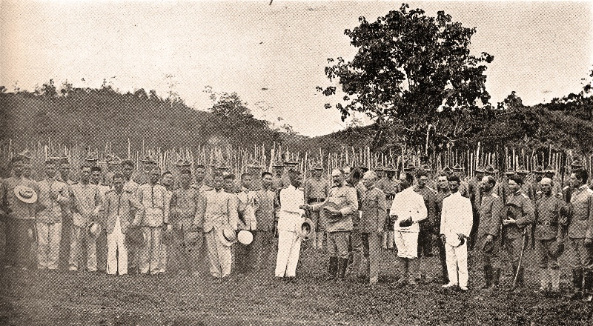**\***

Philadelphia, PA (September 9, 2024)—While much is known about the Spanish-American War and *Olympia*’s role in the conflict, rarely is there discussion about the conflict between the Philippines and the United States, the role the ship played in it or how it became a symbolic lightening rod for the war and lasting impacts of American colonialism. On October 10, 2024, Independence Seaport Museum (ISM) will explore this time in the two countries’ histories in a new exhibit opening aboard *Olympia* entitled *Philippine-American War (1899-1902): Complex Symbols & Conflicting Relationships.* Located in the senior officers’ quarters through December 31, 2025, visitors will learn about the war itself as well as the symbols that arose through the complicated relationship between the United States, the Philippines and the Filipino people. To ensure the most accurate depiction of the war and its outcomes, ISM is partnering on the exhibit with the Filipino Executive Council of Greater Philadelphia, Inc. (FECGP) to include a Filipino perspective.

“We are very excited to be partnering with the Filipino community in the Greater Philadelphia region to bring this exhibition to life. The *Olympia* is the largest artifact in our collection and so it is fitting that it houses this exhibition that tells the story of the events that occurred after the Battle of Manila Bay in 1898,” says Peter S. Seibert, Independence Seaport Museum’s president and CEO.

Told in four sections, the exhibit will first place in context the shifting of power between Spain, the Philippines and the United States of America in the outcome of the Spanish-American War as well as to introduce visitors to the islands of the Philippines and key figures of the time. The second section will highlight the fleeting semblance of freedom for the Philippines only to have it taken away, the United States’ refusal to recognize the First Philippine Republic and the 1899 Battle of Manila, which was the first and largest battle in the war. Section three will delve deeper into the war itself and the advantages each side had within it as well as a look at the United States’ and the Philippines’ positions as well as how they viewed the war and commemorate it to this day. The last section will examine the lasting effects of the conflict, subsequent imperialism and the continued relationship between the countries.

“We are grateful ISM is sharing an often-unspoken part of our nations’ intertwined histories, this time including a Filipino voice in the discussions around this conflict,” says Roman Ventura, president of the Filipino Executive Council of Greater Philadelphia, Inc. “This exhibit will inform generations of Filipinos and Americans alike not only about the Philippine-American War but also its significant influence on the global relationship between the United States and the Philippines up to the present day.”

Since the early 2000s, ISM and FECGP have formally been community partners, with the VFW Pvt. Tomas Claudio Post 1063 having held the first Philippine flag-raising ceremony aboard *Olympia* in 1975. Through these annual celebrations and a desire to illuminate the Filipino perspective, the dialogue about the conflict and changing views within the Filipino community about the two countries’ historical relationship has continued between the two organizations.

*Philippine-American War (1899-1902): Complex Symbols & Conflicting Relationships* is presented by the Independence Seaport Museum in partnership with the Filipino Executive Council of Greater Philadelphia, Inc.

***About Independence Seaport Museum***

*The Independence Seaport Museum (ISM), founded in 1960 as the Philadelphia Maritime Museum, encourages visitors to discover Philadelphia's river of history and world of connections. Stewards of the Olympia, a nineteenth-century cruiser, and the Becuna, a World War II-era submarine, ISM is home to interactive and award-winning exhibitions, one of the largest collections of historic maritime artifacts in the world and a boatbuilding workshop. Accredited by the American Association of Museums since the 1970s, it is a premier, year-round destination adjacent to Spruce Street Harbor Park on Penn’s Landing. Visit daily from 10 a.m. to 5 p.m. and see our full schedule of programs and events at phillyseaport.org.  Visit* [*https://www.phillyseaport.org/admissons-hours-of-operation/*](https://www.phillyseaport.org/admissons-hours-of-operation/) *to learn about ticket packages and guided tour options.*

***About Filipino Executive Council of Greater Philadelphia, Inc.***

*The Filipino Executive Council of Greater Philadelphia, Inc. (FECGP) is a 501(c)3 corporation that* *coordinates events of its 23 member organizations to serve the tens of thousands of Filipinos and Filipino-Americans in the Greater Philadelphia Region, specifically in the counties of Salem, Camden, Gloucester, Burlington, and Mercer in Southern New Jersey; Philadelphia, Delaware, Chester, Montgomery, and Bucks in Southeastern Pennsylvania; New Castle in Northern Delaware; and Cecil in Northeastern Maryland. Since its founding in 1975, the FECGP has continued to bridge the gap between our groups, our youth and our region so we can concentrate our energy in improving the Filipino community. Visit* [*www.theFECGP.org*](http://www.theFECGP.org) *to learn more about the member organizations as well as the events happening in the Filipino Community around the Delaware Valley.*

# # #

*Image: “Insurgent Army Surrenders,” J. D. Givens (1863-1939), from *Scenes taken in the Philippines, China, Japan, and on the Pacific* (c. 1901), photolithograph on paper, Cruiser *Olympia* Association Collection. Caption: “Insurgent Army Surrendering to Gen. Frederick D. Grant in Philippine Islands.”