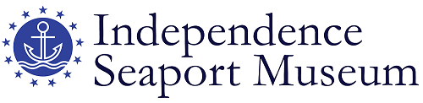

FOR IMMEDIATE RELEASE

Media contacts: Robyn Liverant for Independence Seaport Museum

212.472.6947 or [robyn@robynliverant.com](mailto:robyn@robynliverant.com)

Alexis Furlong, Independence Seaport Museum

610.513.5749 or [afurlong@phillyseaport.org](mailto:afurlong@phillyseaport.org)

**NEW SCHOLARSHIP EMERGES ON FOLK ART MASTERPIECE**

**RECENTLY ACQUIRED BY INDEPENDENCE SEAPORT MUSEUM**

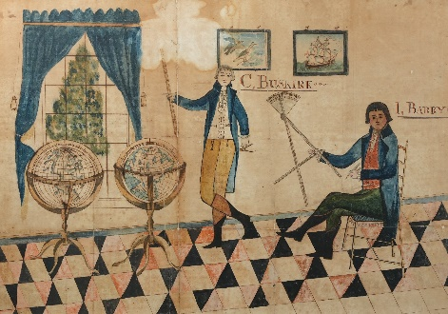 *

Philadelphia, PA (October 17, 2023)—In the late 1700s, when young boys were taught the art of navigation, it was common that they would have used a workbook to write out their examples, trigonometry equations and explore navigational theories. An especially rare example, which includes not only these materials needed for study but also exquisitely rendered watercolor drawings of people, ships, charts and a log from a voyage made in April 1799, was used by a boy named Cornelius van Buskirk (1776-1863). One such watercolor drawing, entitled *Navigation Lesson*, which had been removed from the workbook and retained by the artist’s descendent family, was recently given to the Independence Seaport Museum (ISM) to complement the actual workbook previously given to the museum by a direct descendant’s widow. What makes this already important drawing and larger document all the more extraordinary is that new research conducted by ISM staff shows that the figures in the drawing are of the young artist and his tutor, who is believed to be none other than Commodore John Barry (1745-1803), the man regarded to be the father of the United States Navy.

“The Independence Seaport Museum is thrilled to have been given this wonderful watercolor,” said Peter S. Seibert, president and CEO of ISM. “Not only is it an artistic *tour de force* but we are also now able to reunite it with the original manuscript copy book in our collection. Together, they tell the story of both the father of the U.S. Navy and the young man who was his student.”

The watercolor, which relates in many ways to similar genre scenes from the Federal period, is especially well drawn. It shows “C. Buskirk” receiving a lesson in navigation from “I. Barry” in what appears to be a parlor or study of what is likely Barry’s home. (Van Buskirk Family tradition states that “I. Barry” is Commodore John Barry as ‘I’ is a classical shorthand for ‘J.’) Typical of genre scenes of the time, the room features a black-and-white painted floor, and the overall symmetry of the piece relates it to coastal New England folk artists such as Joseph H. Davis (New England, 1811-1865). Similarly, van Buskirk paid careful attention to the face and hair of the subjects, as did Pennsylvania German artist Jacob Maentel (1763-1863). The size of the drawing (it measures 24.5 inches high by 31.5 inches wide) along with its accurate artistic attention to detail is impressive. Shown against a boldly colorful, geometric background, the scientific instruments carried by the figures are precisely rendered, suggesting that the artist had more than a passing familiarity with maritime navigational tools. Both subjects are holding instruments often used in 18th-century maritime navigation: “Barry” holds a radial arm protractor used to measure and draft angles on paper, while “van Buskirk” holds a Gunter’s scale, which was used to calculate trigonometric functions. “Van Buskirk” is also standing next to two globes—one terrestrial and other celestial—showcasing the interplay of the heavens and the earth in early navigation practices, which relied on positions of the stars for seafaring. Another fascinating element of the work is the inclusion of a pair of naval engagement paintings that the artist incorporated into the background. Having a painting within a larger painting is a technique used by skilled artists to showcase and show off their talents. Such elements raise the artistic level of this work from the casual to the masterpiece.

New research conducted by the Independence Seaport Museum’s curatorial and archival staff support the tradition of the artist’s descendent family of “Barry” being Commodore Barry, based upon stylistic comparisons, life events and family provenance. The darker complexion and size of the older man matches scholarly descriptions of Barry as having a ruddy complexion and a considerably slimmer figure prior to 1790. As he and his fellow officers lost their jobs and were owed back pay after Congress disbanded the Continental Navy, taking small jobs like tutoring a young boy in maritime navigation is not farfetched. Given this, Barry would have been in his 40s and van Buskirk approximately 10 years old, which was an ideal time to learn navigation.

“This painting drew me in instantly when the Independence Seaport Museum received it as a donation,” said Sarah Augustine, archivist at the Independence Seaport Museum. “It is a beautiful representation of early American folk art that provides a visual story of the scholarship and mystique surrounding 18th- century maritime navigation. Since we received this donation, I have been heavily involved in researching van Buskirk, the context of the painting, and the potential connection to Commodore John Barry. I am thrilled that the public will now get to interact with this painting, which was cherished by five generations of van Buskirk’s descendants.”

While it was previously speculated that the entire workbook was completed together in 1799, ISM research points to the first part of the manuscript, which contains the equations and drawings, to have been made prior to the 1799 voyage as it served as a later practicum for van Buskirk.

In 1984, the navigation workbook from which this watercolor was removed, was donated to ISM by Mrs. Schuyler Cammann. In 2023, Maya Muir, Mrs. Cammann’s daughter, donated this painting as well as another watercolor and two portraits to the museum, reuniting the book with this work of art. The painting will be on view in ISM’s forthcoming exhibition that will serve as an introduction to the museum.

If true that van Buskirk is the artist of *Navigation Lesson*, it would identify a new folk artist of considerable skill and talent whose other works have yet to be identified. Research by ISM staff continues on this important and rare document.

*About Independence Seaport Museum*

*The Independence Seaport Museum (ISM), founded in 1960 as the Philadelphia Maritime Museum, encourages visitors to discover Philadelphia's river of history and world of connections. Stewards of Cruiser Olympia and World War II-era Submarine Becuna, ISM is home to interactive and award-winning exhibitions, one of the largest collections of historic maritime artifacts in the world and a boatbuilding workshop. Accredited by the American Association of Museums since the 1970s, it is a premier, year-round destination on the Penn's Landing waterfront. Visit daily from 10 a.m. to 5 p.m. and see our full schedule of programs and events at phillyseaport.org.  Visit* [*https://www.phillyseaport.org/admissons-hours-of-operation/*](https://www.phillyseaport.org/admissons-hours-of-operation/) *to learn about ticket packages and guided tour options.*

# # #

*Image: *Navigation Lesson*, Cornelius van Buskirk (1776-1863), Northeastern United States, ca. 1780s-1790s, watercolor and ink on paper, Gift of Maya Muir, 2023.010.001.